**Session 6**

**-**

**Display devices, LCD display**

**Author:** Guillermo Cortés Orellana

**Teacher:** Tomáš Frýza



Lab assignment

1. **Preparation tasks**

* Table with LCD signals

|  |  |  |
| --- | --- | --- |
| LCD signal (s) | AVR pin(s) | Description |
| RS | PB0 | Register selection signal. Selection between Instruction register (RS=0) and Data register (RS=1) |
| R/W | GND | Pin writing/reading to/from - LCD |
| E | PB1 | Enabling pin. When this pin is set to logical low, the LCD does not care what is happening with R/W, RS, and the data bus lines. When this pin is set to logical high, the LCD is processing the incoming data |
| D[3:0] | - | We won’t use them. They would only be used if we worked in 8 bits mode |
| D[7:4] | PD4, PD5, PD6, PD7 | Four high order bidiriectional tristate data bus pins. Used for data transfer and receive between the MPU and the LCD |

* ASCII values

|  |  |  |  |
| --- | --- | --- | --- |
| Representation | Binary | Decimal | Hexadecimal |
| A | 0100 0001 | 65 | 41 |
| B | 0100 0010 | 66 | 42 |
| C | 0100 0011 | 67 | 43 |
| D | 0100 0100 | 68 | 44 |
| E | 0100 0101 | 69 | 45 |
| F | 0100 0110 | 70 | 46 |
| G | 0100 0111 | 71 | 47 |
| H | 0100 1000 | 72 | 48 |
| I | 0100 1001 | 73 | 49 |
| J | 0100 1010 | 74 | 4A |
| K | 0100 1011 | 75 | 4B |
| L | 0100 1100 | 76 | 4C |
| M | 0100 1101 | 77 | 4D |
| N | 0100 1110 | 78 | 4E |
| O | 0100 1111 | 79 | 4F |
| P | 0101 0000 | 80 | 50 |
| Q | 0101 0001 | 81 | 51 |
| R | 0101 0010 | 82 | 52 |
| S | 0101 0011 | 83 | 53 |
| T | 0101 0100 | 84 | 54 |
| U | 0101 0101 | 85 | 55 |
| V | 0101 0110 | 86 | 56 |
| W | 0101 0111 | 87 | 57 |
| X | 0101 1000 | 88 | 58 |
| Y | 0101 1001 | 89 | 59 |
| Z | 0101 1010 | 90 | 5A |

|  |  |  |  |
| --- | --- | --- | --- |
| Representation | Binary | Decimal | Hexadecimal |
| a | 0110 0001 | 97 | 61 |
| b | 0110 0010 | 98 | 62 |
| c | 0110 0011 | 99 | 63 |
| d | 0110 0100 | 10 | 64 |
| e | 0110 0101 | 101 | 65 |
| f | 0110 0110 | 102 | 66 |
| g | 0110 0111 | 103 | 67 |
| h | 0110 1000 | 104 | 68 |
| i | 0110 1001 | 105 | 69 |
| j | 0110 1010 | 106 | 6A |
| k | 0110 1011 | 107 | 6B |
| l | 0110 1100 | 108 | 6C |
| m | 0110 1101 | 109 | 6D |
| n | 0110 1110 | 110 | 6E |
| o | 0110 1111 | 111 | 6F |
| p | 0111 0000 | 112 | 70 |
| q | 0111 0001 | 113 | 71 |
| E | 0111 0010 | 114 | 72 |
| s | 0111 0011 | 115 | 73 |
| t | 0111 0100 | 116 | 74 |
| u | 0111 0101 | 117 | 75 |
| v | 0111 0110 | 118 | 76 |
| w | 0111 0111 | 119 | 77 |
| x | 0111 1000 | 120 | 78 |
| y | 0111 1001 | 121 | 79 |
| z | 0111 1010 | 122 | 7A |

|  |  |  |  |
| --- | --- | --- | --- |
| Representation | Binary | Decimal | Hexadecimal |
| 0 | 0011 0000 | 48 | 30 |
| 1 | 0011 0001 | 49 | 31 |
| 2 | 0011 0010 | 50 | 32 |
| 3 | 0011 0011 | 51 | 33 |
| 4 | 0011 0100 | 52 | 34 |
| 5 | 0011 0101 | 53 | 35 |
| 6 | 0011 0110 | 54 | 36 |
| 7 | 0011 0111 | 55 | 37 |
| 8 | 0011 1000 | 56 | 38 |
| 9 | 0011 1001 | 57 | 39 |

1. **HD44780 communication**

* Picture of time signals between ATmega328P and HD44780 (LCD keypad shield) when transmitting data **DE2**

**DE2 = 0100 0100 – 0100 0101 – 0011 0010**

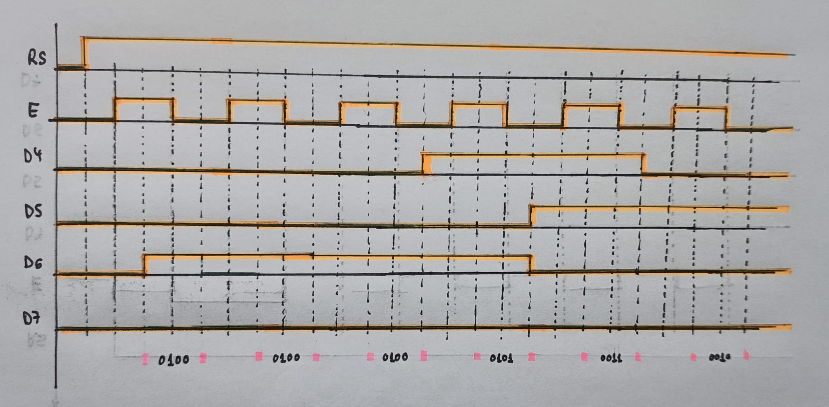

1. **Stopwatch**

* Listing of **TIMER2_OVF_vect** interrupt routine with complete stopwatch code (minutes:seconds.tenths) and square value computation

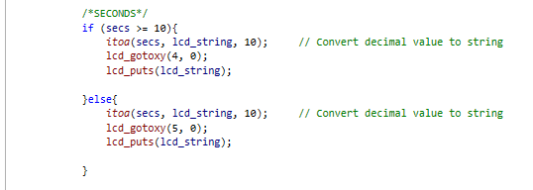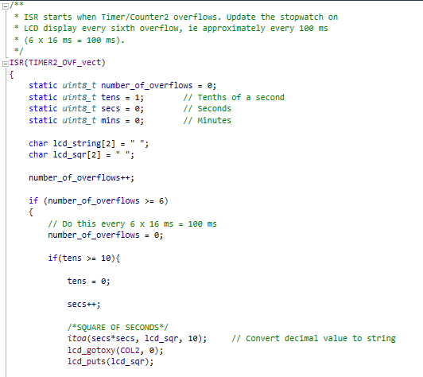

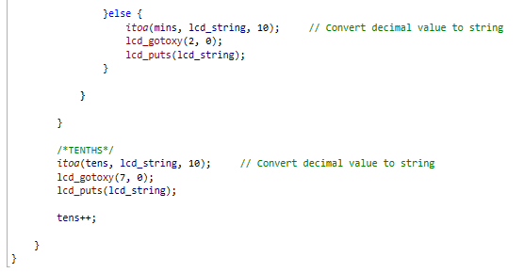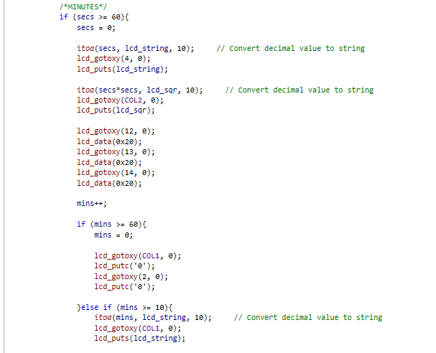

You can find the code on my GitHub:

https://github.com/GuicoRM/Digital-Electronics-2

* Screenshot of SimulIDE circuit when “Power Circuit” is applied

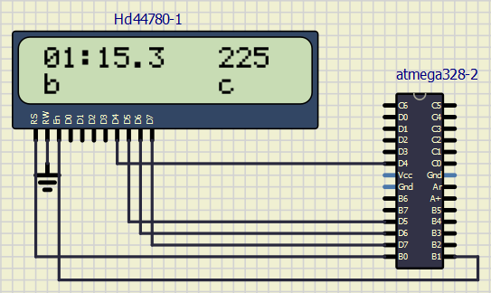

1. **Progress bar**

* Listing of **TIMER0_OVF_vect** interrupt routine with a progress bar

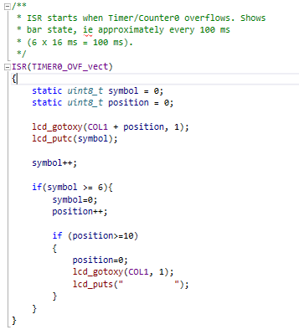

You can find the code on my GitHub:

<https://github.com/GuicoRM/Digital-Electronics-2>

* Screenshot of SimulIDE circuit when ”Power Circuit” is applied

**Note:** I also added one custome character (‘chessboard’) in position ‘c’ in order to test it

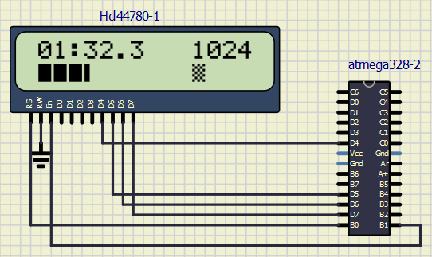

**Position ‘c’**

You can find the code of **custome** **character** on my GitHub:

<https://github.com/GuicoRM/Digital-Electronics-2>

1. **EXTRA**

* From the LCD position "c", displays running text, ie text that moves characters to the left twice per second

**Note:** I achieved to show moving text ‘I like DE2!’ in rudimentary way. It probably won’t be the best way to get moving text, but it works.

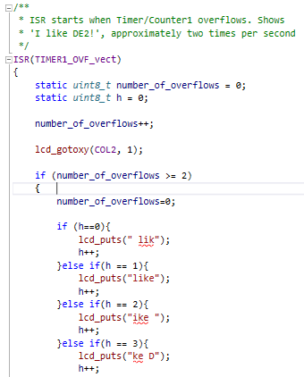

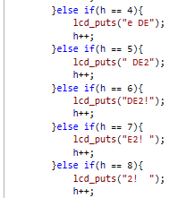

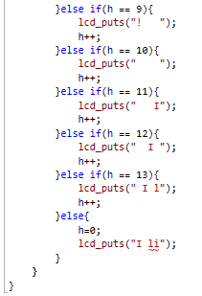

You can find the code of **custome** **character** on my GitHub:

<https://github.com/GuicoRM/Digital-Electronics-2>

* Screenshots of SimulIDE circuit when ”Power Circuit” is applied

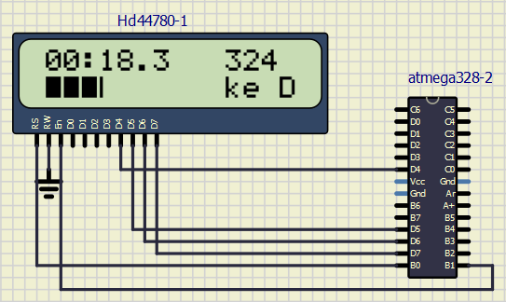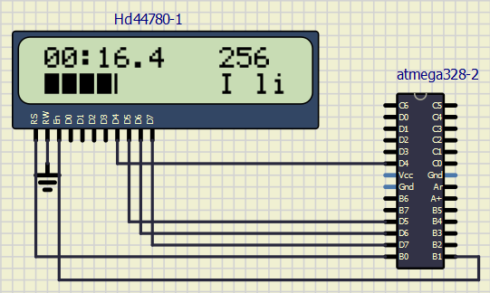

You can find the code of **custome** **character** on my GitHub:

<https://github.com/GuicoRM/Digital-Electronics-2>